Welcome to Coaching AYSO and thank you for volunteering.
2025 Note: Where it refers to Coordinator or Division Coordinator, please refer to the Region Commissioner. In the future, I’d like to find more board volunteers that will be willing to support.
If you registered your child under your account, then you will register as a volunteer under your account. If your child is registered under a family member’s account, then you will want to get added as a volunteer under that account. We do keep children with their volunteers, and ensuring you use that same account means they are flagged in the system.
Step 1 – Sign into the account where your child is registered http://www.ayso669.org It is best to use a Microsoft internet browser. If you are struggling using a phone or tablet, you’ll want to try a different browser or use a computer.
Step 2 – Use the sidebar to get to the Volunteer page and either open by clicking on the 3 lines in the left corner and select the “VOLUNTEER” option OR click on the “person” on the left of the screen. 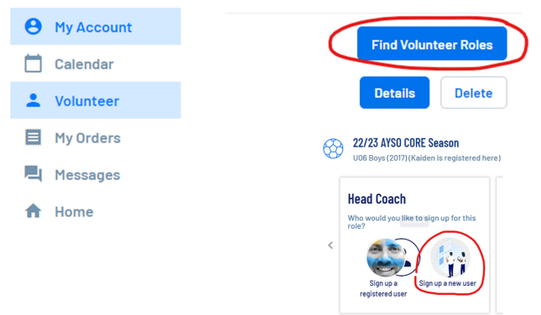
Step 3 – Select “FIND VOLUNTEER ROLES” in the middle or top right of the page.
Step 4 – Select “Head Coach” Follow the steps as yourself and fill in any needed information. If your name isn’t showing, sign up as a new volunteer and follow those steps. If your child is already registered under your account then finish filling out the forms and skip to STEP 10.
Step 5 – Complete the forms, Accept the Kids Zone Pledge, COVID‐19 Waiver, and Consent/Release Forms 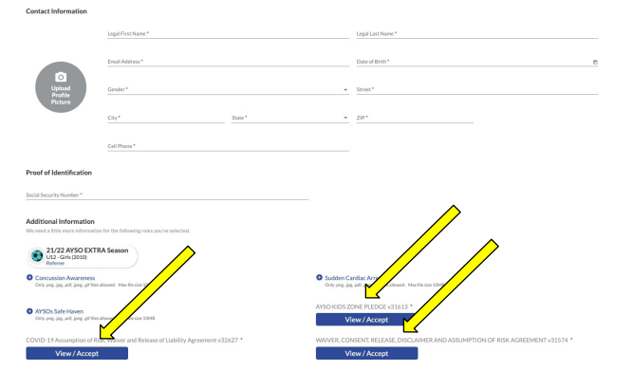
Step 6 – Click the “Invite User and Continue” button
Step 7 – Create new account with your email address. You will receive an email to finish setting up your account.
Step 8 – Click the button to “Accept Invite”
Step 9 – Complete the form to finish setting up your account and register as Coach.
Step 10 – Complete Background Check. You will receive an email from Sterling Volunteers to complete your Level 2 Background Check. If you don’t see the email in your Inbox, be sure to check your spam folder.
Step 11 – Now wait 24 hours. AYSOU, where you will receive your online training, only syncs with AYSO’s Login/Password database once every 24 hours. If you attempt to sign in to AYSOU immediately after creating your AYSO account, you will not be able to log in
Page Step 12 – From the same Sports Connect account as above, click the VOLUNTEER tab to the left of your screen and under Find Volunteer Roles, click on “AYSOU” This will take you to the eTrainU site to complete the required trainings:
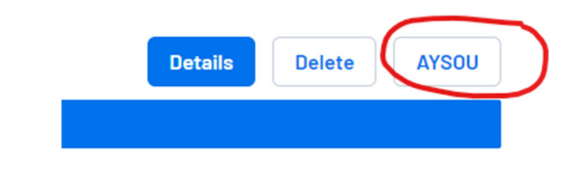
- CDC Concussion Awareness
- Sudden Cardiac Arrest
- AYSOs Safe Haven
- Safe Sport
- Coaching certificates (ie U6, U8, U10, etc)
Once your trainings are complete, the following year you will only need to re‐register as a volunteer, renew your background check and renew SafeSport-which has a minimized training for renewal. Fingerprinting is not required.
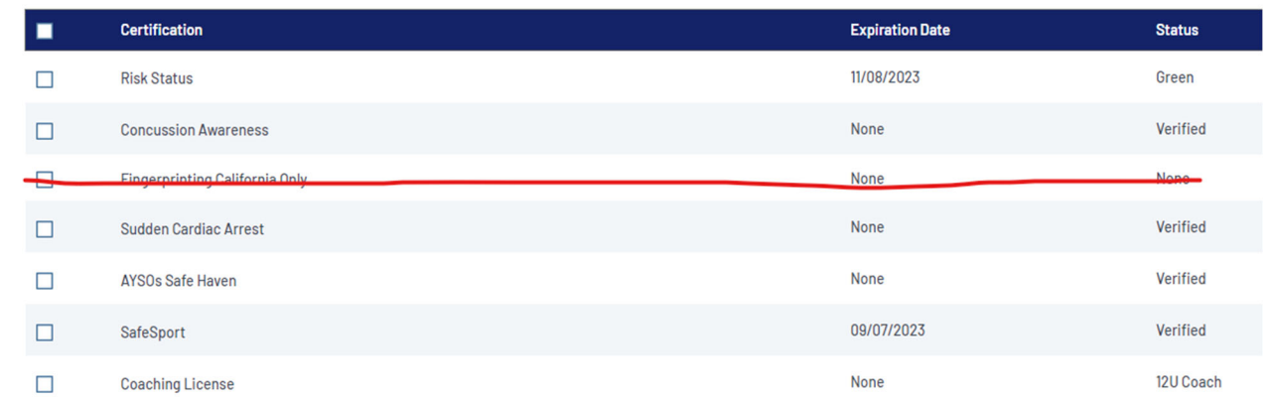
Step 13 – From the AYSOU button, you will be directed to the eTrainU website. Select the "Training Library" tab on the left side.
- U4 Playground,
- U5 Schoolyard,
- U6 Coach, and
- U8 Coach are available online.
The region will typically hold a field training session to help coaches with practices for these divisions but is not mandatory.
We will typically hold a U12 In Person and Field Training each Fall and Spring for U10 and up coaches. There is an online precourse for U10 and U12.
2025 Update: There are a number of trainings available yet this year. Please reach out and we will work with Coach Trainers to fill in as well.
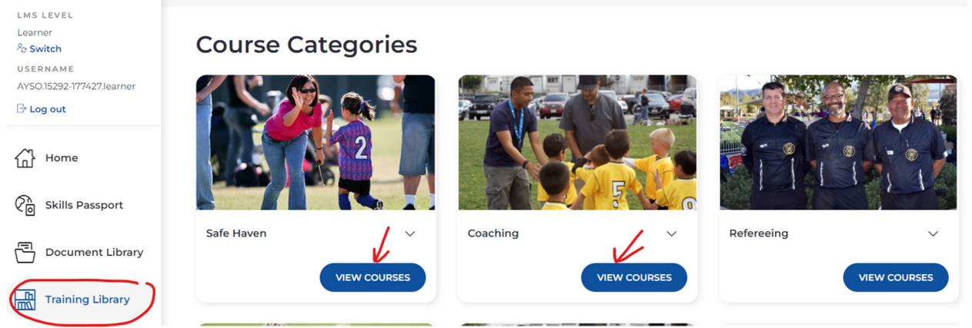
For SafeSport, you will need to click the check box next to the training on the Volunteer tab and then click the renew button.
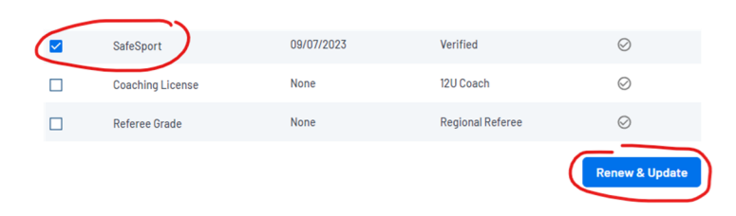
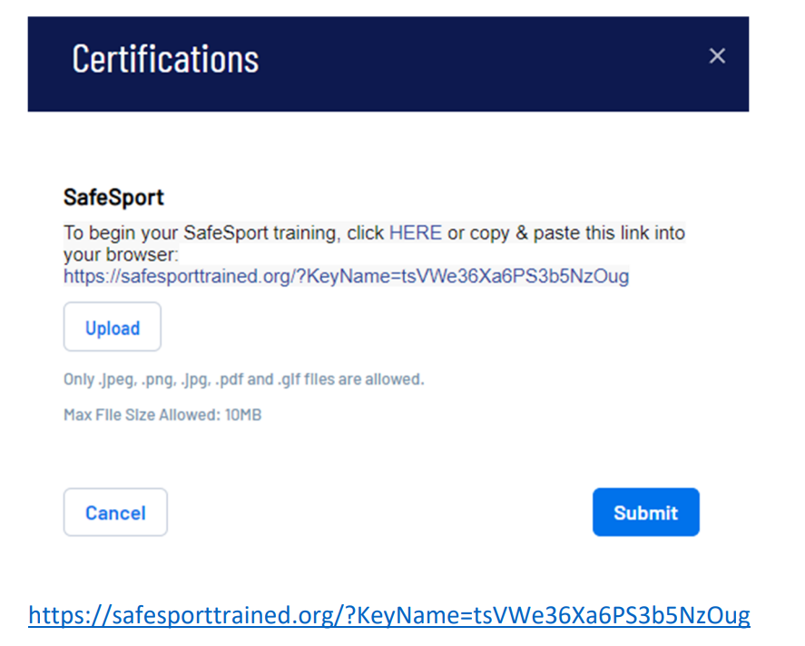
Step 14 – Confirm that your training is complete and notify your division coordinator. YOU DID IT! Send a screenshot or picture to your coordinator of your completed training. Your “Risk Status” section should show a valid expiration and “Green” status‐ regardless of “Compliant” check mark.
Step 15 – Attend the Pre‐Season Coaches Orientation Meeting. Even if you are a returning coach, you will benefit from the refresher, learn what’s new with AYSO and the Laws of the Game and receive your roster and uniforms. You will only need to attend on of the days that the meeting is held. Find out from your coordinator if they will be attending both meetings to make sure you attend one that you will be able to get your roster and uniform at.
Typically, the coordinators will attend each of the meetings but not always.
Coaches will receive:
- Hard copy team roster
- Player forms in a folder
- Coach Acknowledgement Form
- Coach bag with ball and equipment (typically first aid kit, whistle, cones)
- Uniforms
After attending the pre‐season meeting and receiving your roster, your coordinator will also provide an electronic copy of the roster, and you can schedule your team meeting and begin holding practices.
Step 16 – Finding your team roster online
From the Volunteer Tab – Click on Visit Team Page
Go to Roster Tab, make sure to click on the boxes as shown and generate roster.
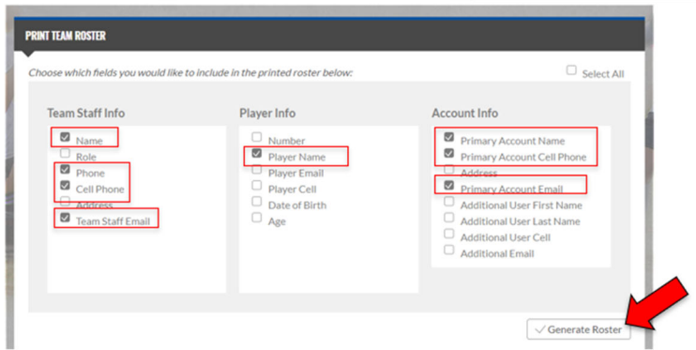
Keep in mind that the roster that your coordinator sends to you will contain a complete list of information for each player, above and beyond what coaches are able to generate from the team page
Make sure you’re able to get a hold of each of your players for the team meeting. Consider using an App to manage your team communication.
COACH RESOURCES Coaches Manuals for each division can be found on AYSOU. These have great resources for lesson plans. YouTube is also a great resource for finding training activities.
